Orators Report
on the 26nd Degree
Prince Of Mercy,
or Scottish Trinitarian
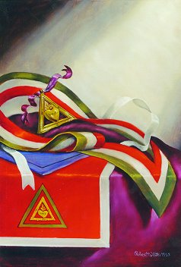
Mar 6, 2013

The Apron is scarlet with a whiteborder. In the center is a equalateral triangle’ The colors green, red, and white symbolize the Masonic Trinity
Bremerton Valley of the Scottish Rite

The Legend: The Council of Kadosh comprises the Nineteenth through the Thirtieth Degrees. The word Kadosh is Hebrew, and means “consecrated or dedicated.” Its members are dedicated to the discovery of philosophic truths and the chivalric virtues.
In a system of degrees to complete the Scottish Rite, it was necessary to teach every religion and philosophy known. In the 24th Degree, the ancient mysteries of some of the world's major religions are interpreted. In the 25th Mohammedanism is presented. The 26° takes us into the early Christian mysteries just as the preceding Degrees have taken us into the mysteries of other faiths. We are told that in the earliest days, Christianity was taught by a series of initiations, echoes of which still survive today in the Baptism of the Catechumens and the Mass of the Faithful.
The Setting: is a representation of the catacombs under Rome. It has been said that the lives of the early Christians consisted of "persecution above ground and prayer below ground." When danger and death hung on their footsteps, the Christian Masons met in the Catacombs, —an assemblage of whom is represented in this Degree of Princes of Mercy, who were representatives of the faithful by means of God's Triple Covenant - with his people, with the world, and with man - that the day should come when light, truth, and happiness should be victorious over darkness, error, and misery.
The Ritual: The Chapter has gathered in the catacombs. the candidate, representing Constans and dressed in a plain black robe, seeks entrance that he may be initiated and become one of the Faithful. Having been sufficiently assured of the candidate's sincerity and character, the doctrine that is presumed to have been that which was divulged in the last degree of the Christian Mysteries is presented: the belief in the resurrection.
Parallels are drawn between the slaying of Hiram and. the death of Jesus. The malignant priests, wishing to silence Jesus, incited the populace to demand the execution of the friend and benefactor of mankind; in the story of Hiram the first assassin, who struck on the throat, is representative of the priests and the rule he used represents the priesthood. Jesus was likened to a king by Pontius Pilate and the priests said "we have no king but Caesar." The second assassin uses the square, symbolic of despotism, to strike at the heart, the birthplace of all gentle and loving affections. The general populace chose not to release Jesus, but another. They and the setting maul, which struck at the seat of the intellect, are symbolic of that brutal ignorance which causes humanity to hate learning and the enlightened mind.
The three columns of the Masonic temple: Wisdom, Strength and Beauty are typified in the characters of King Solomon, King Hiram and the Master Hiram. They also, by their number, remind us of the Christian Trinity: the Father, the Son and the Holy Spirit. The Master's Word symbolizes the new religion, the New Law of Love, brought to the world by Jesus. The true Prince of Mercy obeys the New Law of Love taught in the 18th Degree. He imitates the mercy, goodness and beneficence of God the Father in heaven. The instruction on the Trinity and the parallels between the symbolism of Christ and Hiram prepare the candidate for the obligation.
The Lecture: We are told of the basic beliefs of many of the world's ancient religions and shown that the idea of Trinity was central to most of them. Almost all religions have conceived of the Deity as having the attributes of Wisdom, Strength, and Beauty or of Harmony or Balance (the last three being largely synonymous). Another way to say it is that God must possess the Intellect to conceive a universe, the Power to create it, and the sense of Harmony or Equilibrium to bring that Intellect and Power together in such a way as to create. While we may think of that idea as belonging to the Judeo-Christian tradition, it is, in fact, difficult to find an ancient religion which did not hold much the same view.
Not all philosophers agree with the above interpretation of the Trinity. Suffice it to say that the Masonic Trinity is not intended to be considered the Trinity of Christian doctrine or of any other religion.

THE LESSONS OF THE 26° are forgiveness and toleration. Obviously, those ideas are closely linked. People primarily offend against others through intolerance. Most of the trespasses against you, which you are called upon to forgive, are the result of intolerance of one form or another. Surely, then, you have an obligation not to offend against others in the same way.
DUTIES: Practice mercy (forgiveness).
Be tolerant.
Be devoted to the teaching and diffusion of the true principles of Masonry.
FOR REFLECTION
"What is truth?" (Pontius Pilate, John 18:38)
IMPORTANT SYMBOLS:
The numbers 3 and 9, triple interlaced triangle (9 pointed star), arrow, tessera or mark, the colors red, green and white. Green is symbolic of the infinite wisdom of the Deity. Red is symbolic of His unlimited power or force. White symbolizes divine harmony, since it is produced by the presence of all colors in perfect proportion.
The apron is scarlet, with a wide border of white. In the center of the apron is a green equilateral triangle. Within the green triangle is the jewel, embroidered in gold. The flap of the apron is sky blue. The jewel of the 26° is an equilateral triangle of gold. In the center of the triangle, also of gold, is a flaming heart.
"We utter no word that can be deemed irreverent by any one of any faith. We do not tell the Moslem that it is only important for him to believe that there is but one God, and wholly unessential whether Mahomet was His prophet. We do not tell the Hebrew that the Messiah whom he expects was born in Bethlehem nearly two thousand years ago; and that he is a heretic because he will not so believe. And as little do we tell the sincere Christian that Jesus of Nazareth was but a man like us, or His history but the unreal revival of an older legend. To do either is beyond our jurisdiction." Albert Pike Morals & Dogma 26th Degree.

This report is based on excerpts from: "Toward the Light, The Work" – 1999, Orient of OK;
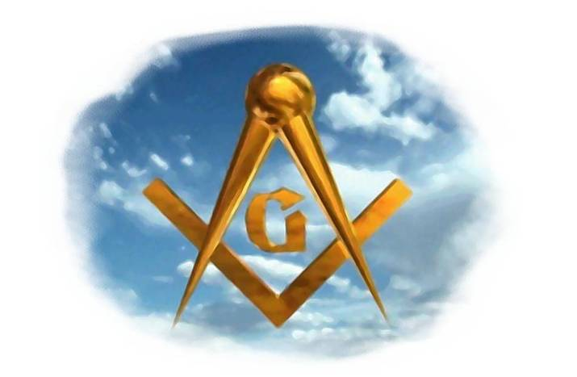
"Bridge to Light" – 2006, Rex Hutchins; “26th Degree” Tresner, "Scottish Rite Ritual, Monitor and Guide" – 2007, Arturo de Hoyos.

